**National University of Computer and Emerging Sciences**



**Laboratory Manual**

*for*

# Data Structures Lab

|  |  |
| --- | --- |
| Course Instructor | Mr. Uzair Naqvi |
| Lab Instructor(s) | Seemab Ayub, Lubaina Zubair |
| Section | BCS-3H |
| Date | Wed, Dec 6, 2023 |
| Semester | Fall 2023 |

# Department of Computer Science

FAST-NU, Lahore, Pakistan

**Objectives:**

In this lab, students will practice:

1. Graphs
2. BFS and DFS

**Problem 1:**

Create a program to count the number of connected components in the undirected graph below using Depth-First Search (DFS):

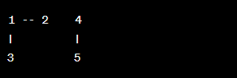

**Problem 2:**

Consider the directed acyclic graph (DAG) below:

Write a program to perform topological sorting using Depth-First Search (DFS). Print the topological order.

**Problem 3:**

Implement a program to find the shortest path between vertices 1 and 4 in the weighted graph. The graph is represented using an adjacency list:

function should count the number of connected components in a graph using Depth-First Search and take the graph as input and return the count.

**Problem 4:**

Given the following undirected graph represented using an adjacency list:

Write a program to Implement a class for graph with methods to add an edge, perform Breadth-First Search, and print the connected components. Test the class with a sample graph also print the BFS traversal.

**Problem 5:**

Given the weighted undirected graph represented by the adjacency list below:

Write a program to find the minimum spanning tree (MST) using Kruskal's algorithm. Print the edges of the MST.

**Problem 6:**

You are given the following undirected graph representing a subway system:

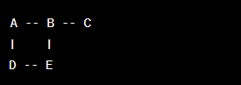

Write a program to find the number of stations you need to pass through to travel from station A to station C using Breadth-First Search (BFS).